AJAB -

Functionality
You use the year-end closing program to close the fiscal year for one or more company codes from an accounting perspective. Once the fiscal year is closed, you can no longer post or change values within Asset Accounting (for example, by recalculating depreciation). The fiscal year in Asset Accounting that is closed is always the year following the last closed fiscal year in Asset Accounting. You can not close the current fiscal year until all depreciation values have been posted.

Scenario
All required steps before year-end closing have been completed including depreciation for all relevant periods (refer to Preparation for Year-end Closing )

Requirements
You have run the report “ABST2” Account Reconciliation and reconciled the asset ledger with the general ledger. Depreciation should have been completely posted.

Menu Path | Accounting → Financial Accounting → Fixed Assets → Periodic Processing → Year-End Closing → AJAB - Execute
Transaction Code | AJAB

1. Double Click on AJAB - Execute
Year-End Closing Asset Accounting

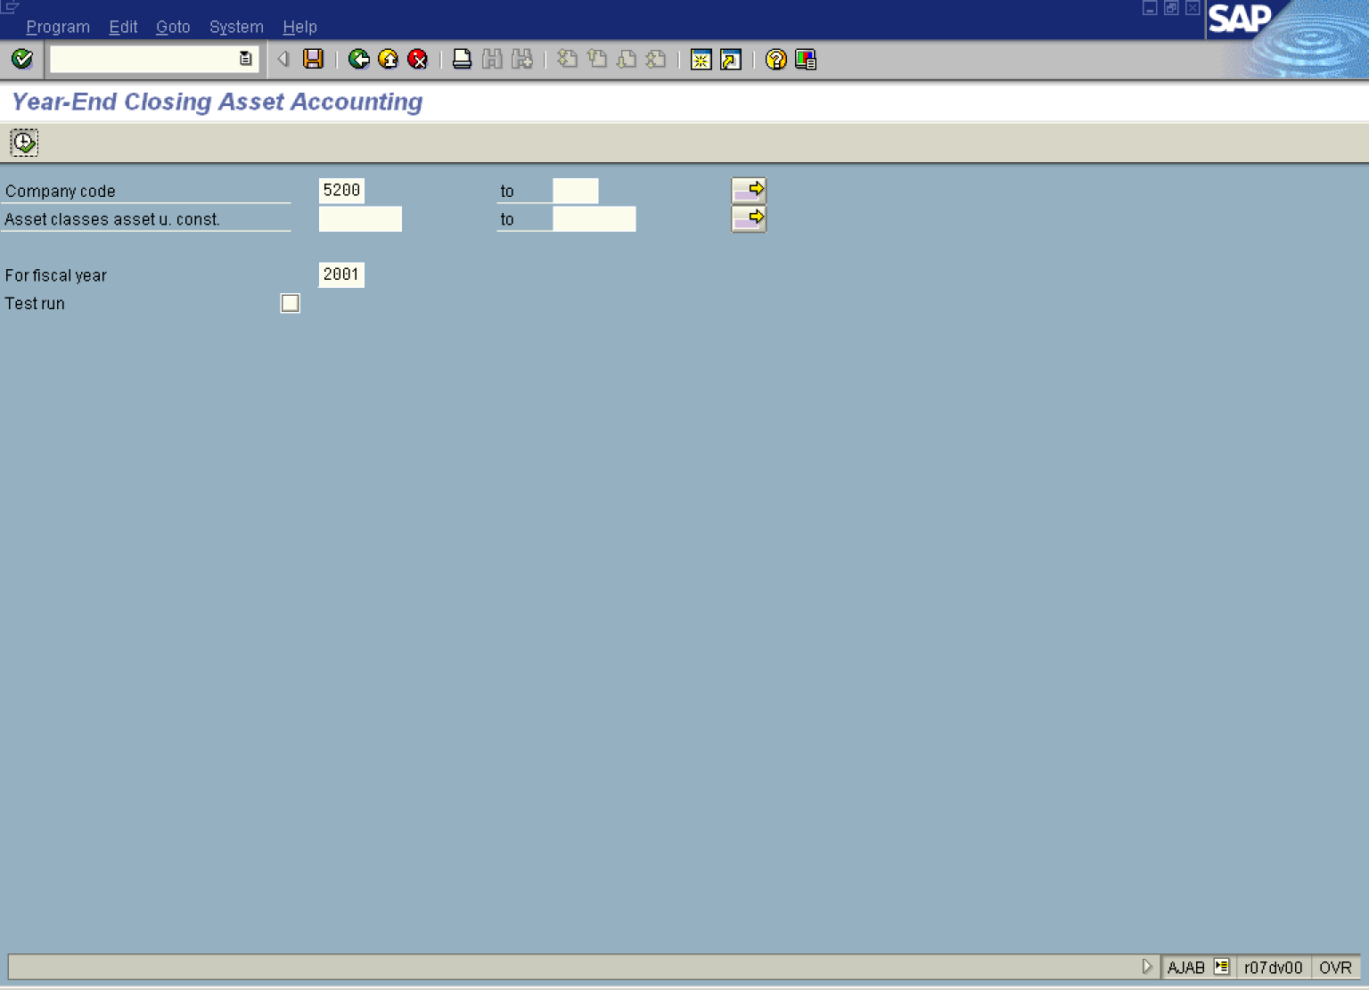
2. Update the following fields:

Field Name | Field Description | Values
Company code | The company code is an organizational unit within financial accounting. | Example: 5200
For fiscal year | Period, 12 months as a rule, for which the company is to create its inventory and balance sheet. | Example: 2001
3. Deactivate the Test Run button Test run .
Note: This option controls whether or not a test run takes place.
If Test run is active, the system only generates a log. Data is neither updated nor changed in the database. This can be performed in foreground.
If Test run is not activated, the system updates data in the database. This must be performed in BACKGROUND.
4. Select ProgramExecute in background.

Background Print Parameters

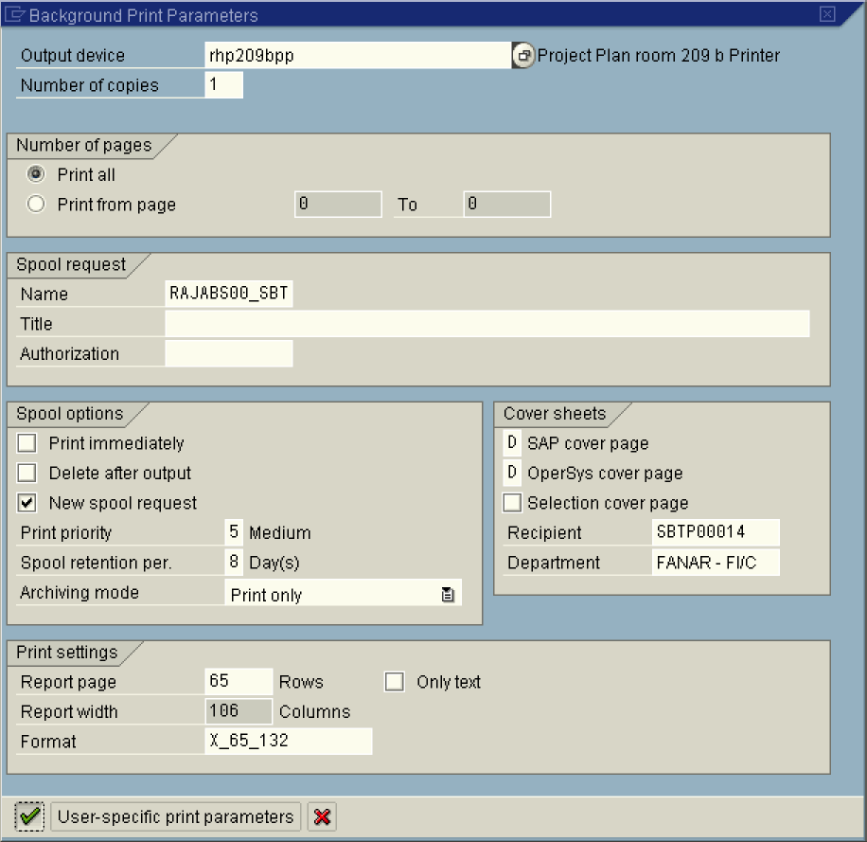
5. Update the following fields:

Field Name | Field Description | Values
Output Device | Code that identifies your printer.  NOTE: this can also be local to print on your the default windows printer. | Example: rhp209bpp. NOTE, this can also be local to print on your the default windows printer.
6. Click the Enter button to confirm your entries.

Start Time

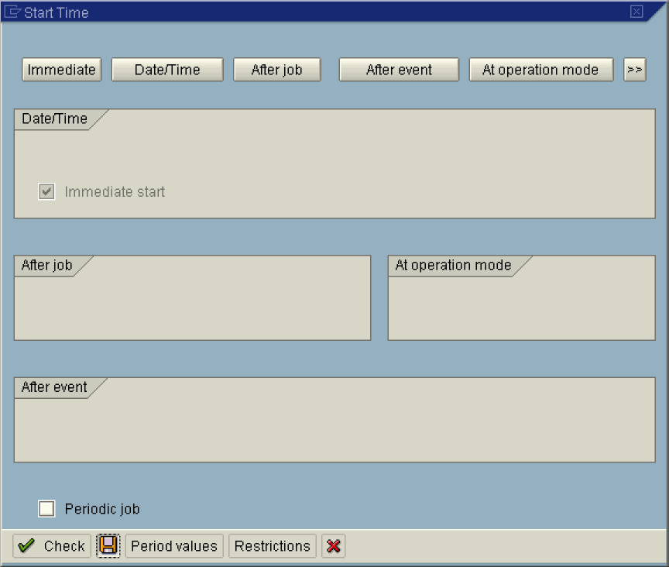

7. Click Immediate button.

Note: To run the job at a later time or after a specific event, select the relevant button. or .

8. Click the Save button.

Year-End Closing Asset Accounting

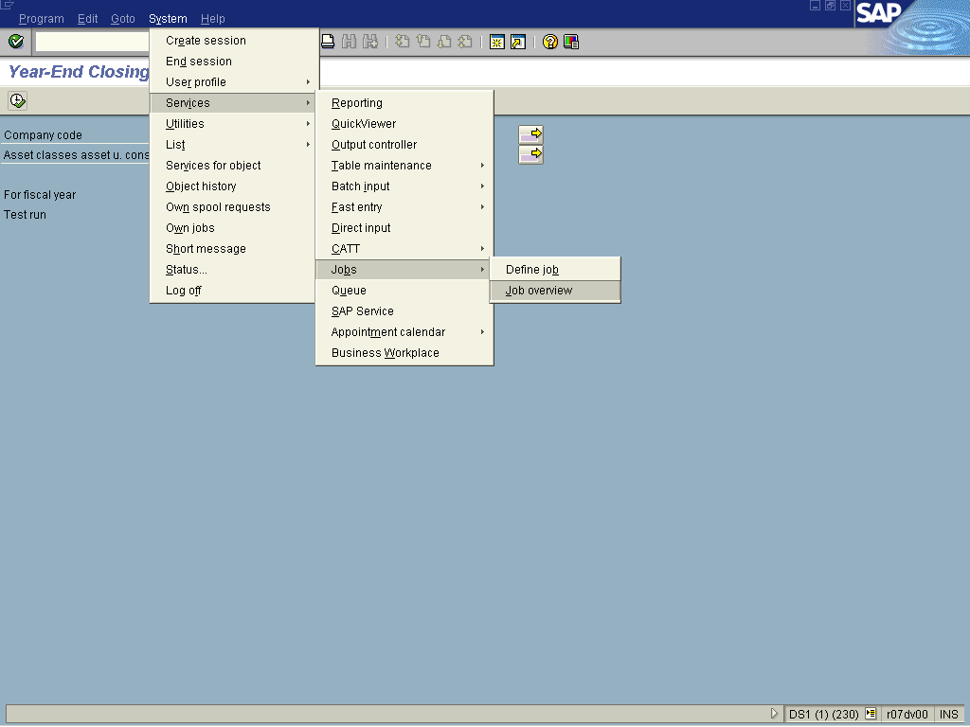

9. Select SystemServicesJobsJob overview.

Simple Job Selection

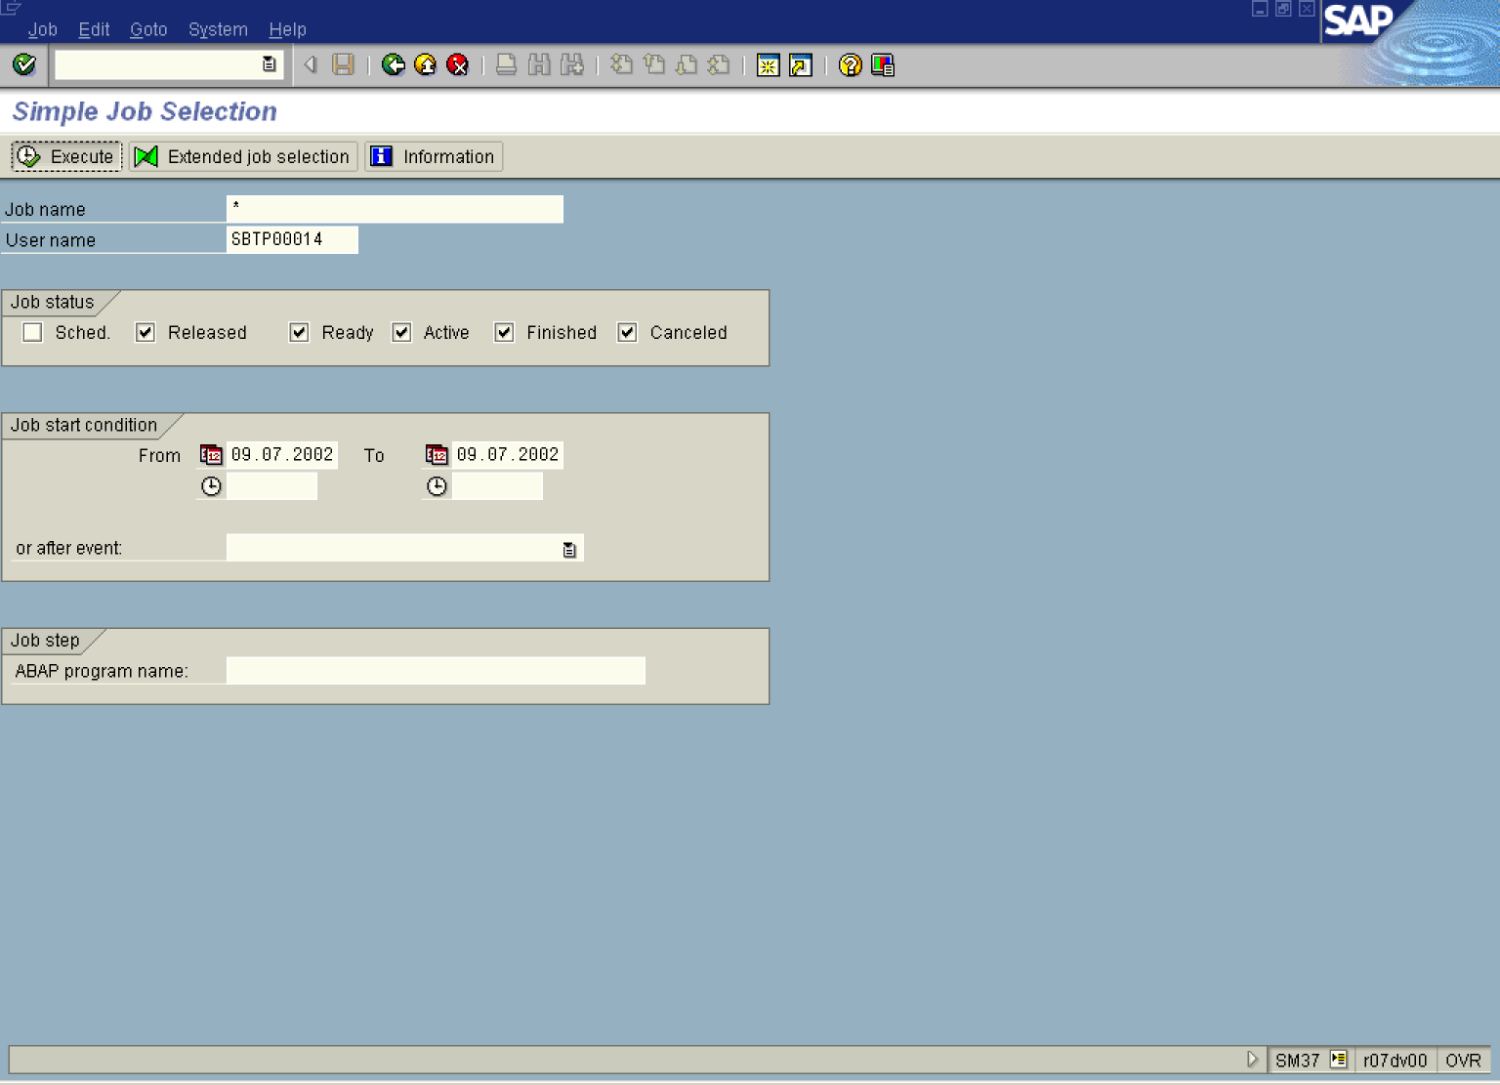
10. Click Execute Button .

Job Overview

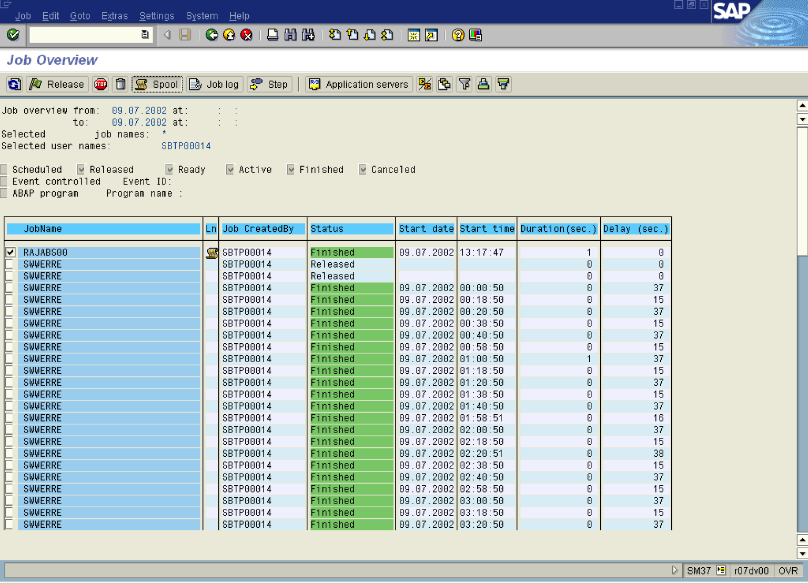

11. Click RAJABS00 Button .
12. Click Spool Button .

Output Controller: List of Spool Requests

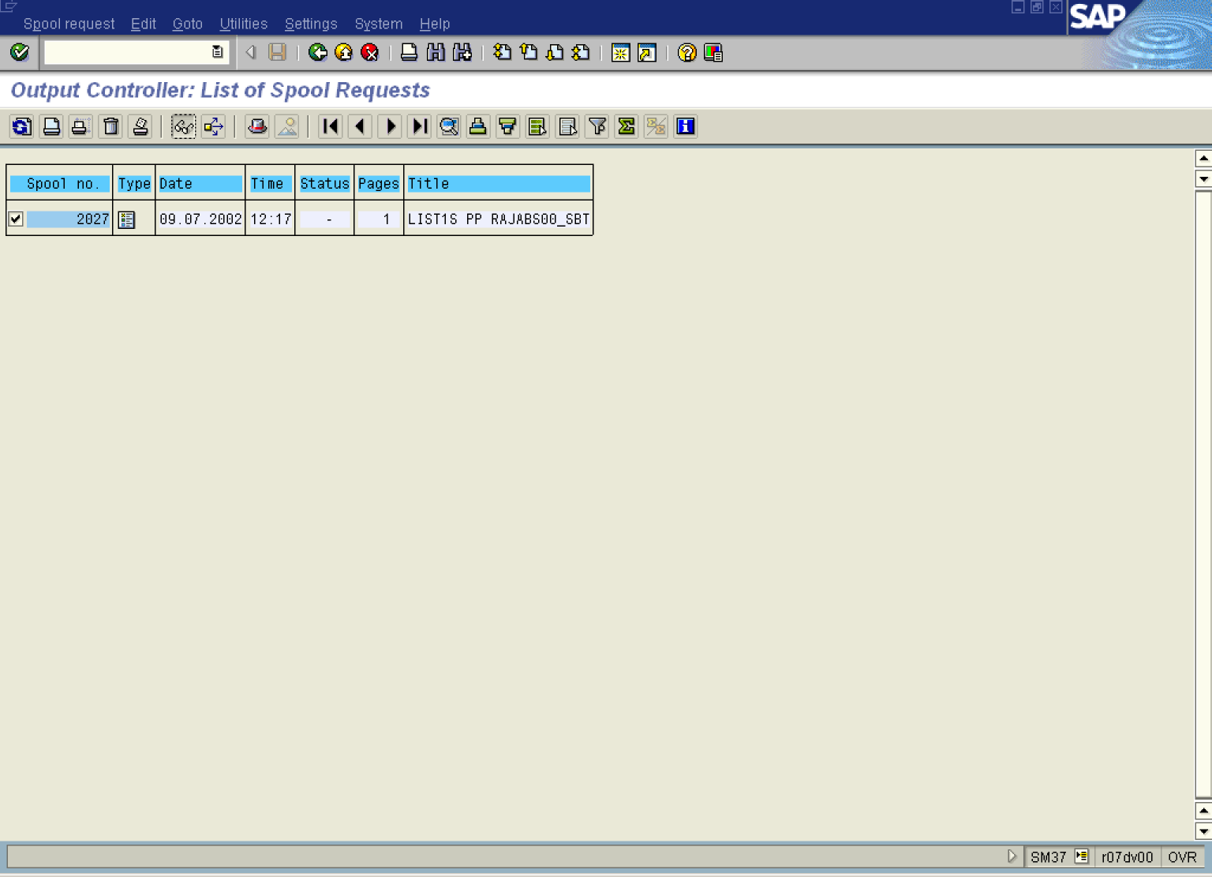
13. Click 2027 Button .
14. Click Display button.

Graphical display of spool request 2027 in system DS1

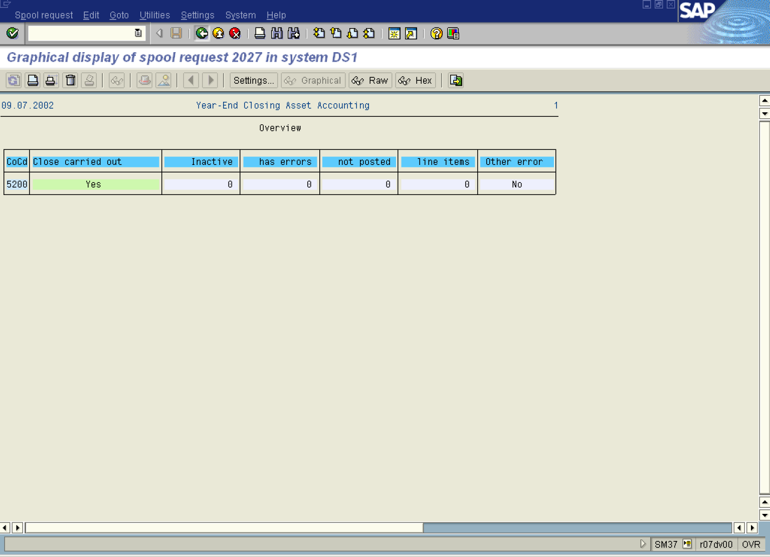
15. The system displays a status message of the transaction.

